2011
a CMSC_127 System: Employee Training

PRINCESS CUABO && KIM PENTIN

[User Manual]
PERSONNEL – TRAINING MANAGEMENT SYSTEM

WHAT IS UP MIN ERP PERSONNEL-TRAINING MANAGEMENT SYSTEM?
Personnel-Training Management System records and organizes the attended workshops, conferences, seminars and the like of University personnel.This will provide necessary details such as dates, locations, participants and organizers about specific trainings,both organized by the Universityand non-UP, on which at least one personnel of the university have attended. The system also includes document-uploading provision for certificates or other proofs of participation of a user in a specific event.

USER TYPES
The system has 2 users:
- ADMINISTRATOR (super user) – the administrator can do the following in the system
  - VIEW all trainings in the database, with all of its details:
    - training title
    - training type
    - description
    - time period
    - organizer(s)
    - location, city
    - remarks, and
    - its associated budget
    - all participants, both from UP and non-UP, and their certificates
  - ADD a training
  - EDIT a training
  - DELETE a training
- USER (limited user) –
  - VIEW trainings in which he/she have participated and its details.
  - DOES NOT VIEW all participants of a training
  - ADD and EDIT a training
  - DELETE his/her training but does not delete the training in the training database

LIST OF ENTITIES WITH ATTRIBUTES
- PARTICIPANT, fetched from another database, upmin_setup
(userID, officePersonnelID, username, passWord, email, completeName, status, userType, lastVisit)
- TRAINING
(training_id, training_title, start_date, end_date, location, city, remarks, organizer, type, description)
- BUDGET
(budget_id, budget_actual, budget_allocated)
- PARTICIPANT – TRAINING
(participant_id, training_id)
Figure 1.
PERSONNEL
PERSONNEL - TRAINING
TRAINING
FINANCE
This diagram shows the relationship between entities given their respective cardinalities. A participant may have none or many trainings. A training is attended by at least one personnel. A budget has a one-to-one relationship with the training.
Figure 2
This Entity Relationship Diagram shows each entity with their respective attributes and other specifics.
- PARTICIPANT – entity for the university faculty or staff
- TRAINING – defines the workshop, seminar, conferences, etc.
- BUDGET– defines the money matters of an event
- PARTICIPANT – TRAINING – bridge table for the personnel and the training. This shows the link between the personnel and the training

LOGGING IN
To log in, type in your Username and Password in their corresponding input boxes and then click the button with the label ‘Login’. If you want to reset the fields click the button indicating ‘Reset’.

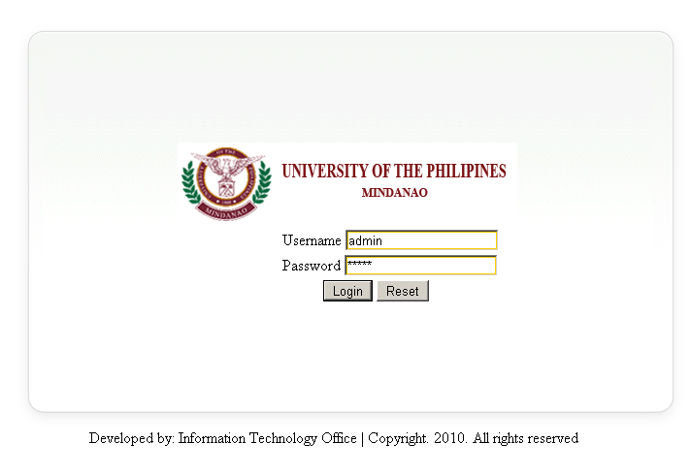
Figure 3 Login Page

After logging in, click on the ‘Personnel Trainings’ if your and Administrator, or ‘My Trainings’ if your using the limited user type.
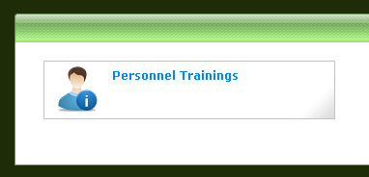 ‘Personnel Trainings’ for Admin Type

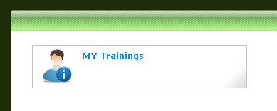 ‘MY Trainings’ for User Type

HOW TO VIEW TRAININGS
By default, admin level view will be directed to the list of all trainings in the database. Basic information (training ID, training title, location and city) about the trainings are initially showed.
Users will be directed to the list of his/her own trainings with its basic information – training ID, training title, location and city.
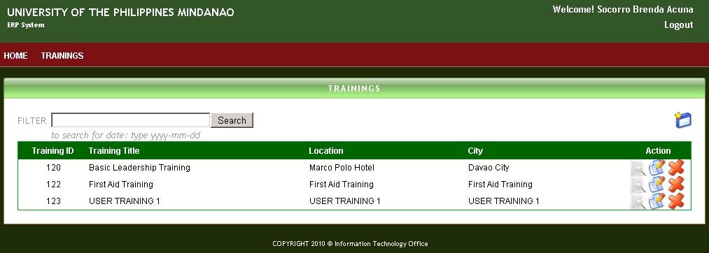
To view the details of a training, click the first icon under the ‘Action’ parallel to the training that you want to view | 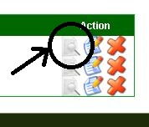

It will now redirect the user to another page, showing the details of the training:

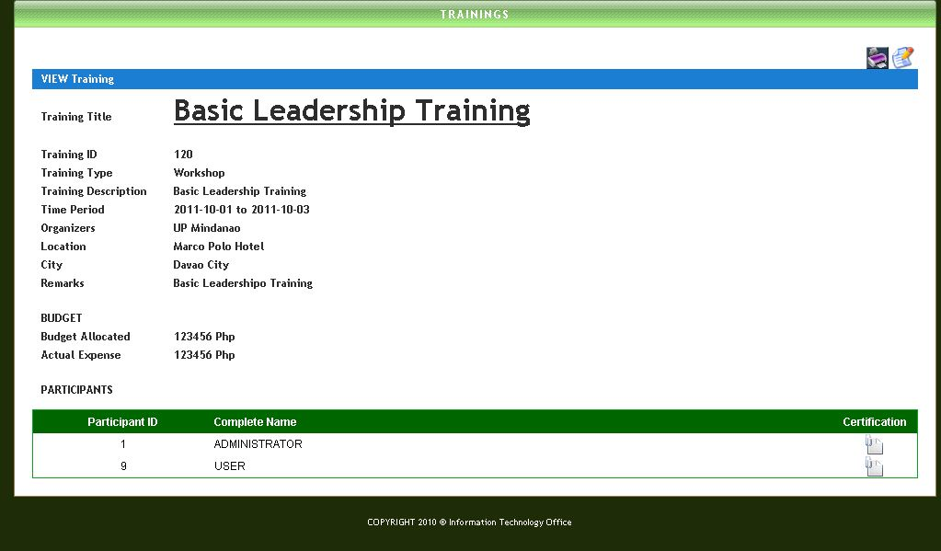
To print the page click the 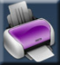 icon on the upper right of the page.
To view the certificate of a participant, click the  icon under the certification column on the PARTICIPANTS table.
For users, viewing their certificate will require them to view the training, as shown on HOW TO VIEW TRAININGS, then click the icon on the bottom of the page.

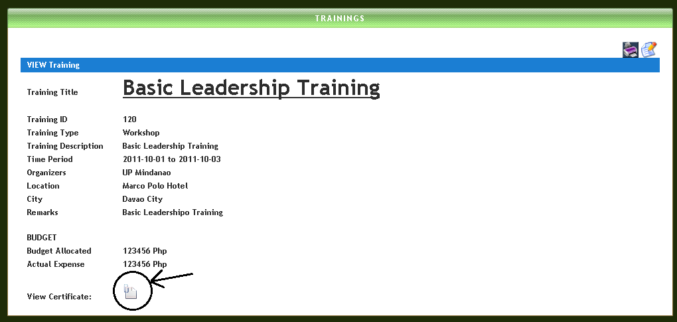

HOW TO ADD A TRAINING
To add a training, look for  icon on the upper right of the page, then click it.
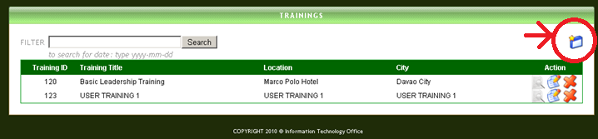

It will now redirect you to a page which looks like this:
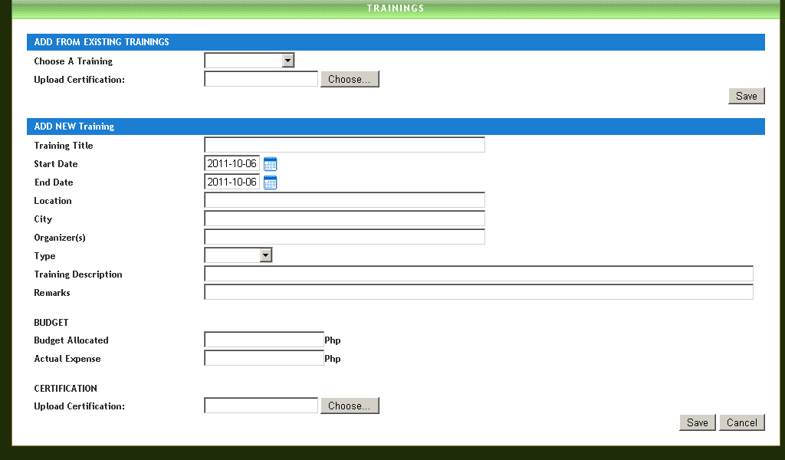

To add from existing trainings, just fill in the upper part of the form by choosing from one of the options in the drop down menu on the right of ‘Choose A Training’.
After that, upload a certification by clicking the button ‘Choose…’ and then choose the file which proves your participation in the training you selected beforehand then click ‘Save.’
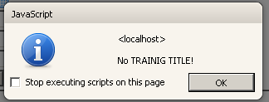
If the training does not exist yet in the database, fill in the lower part of the form. After filling the blanks have been finished, click ‘Save’.
Warning errors appear, such as ‘No Training Title!’ or ‘No Location!’. If this happens, recheck the input fields if it has been properly filled in.

HOW TO EDIT A TRAINING
There are 2 ways to edit a Training:
First, in the default view (the view wherein the list of trainings is showed), click the second icon under the ‘Action’ column. The icon should look like this: .
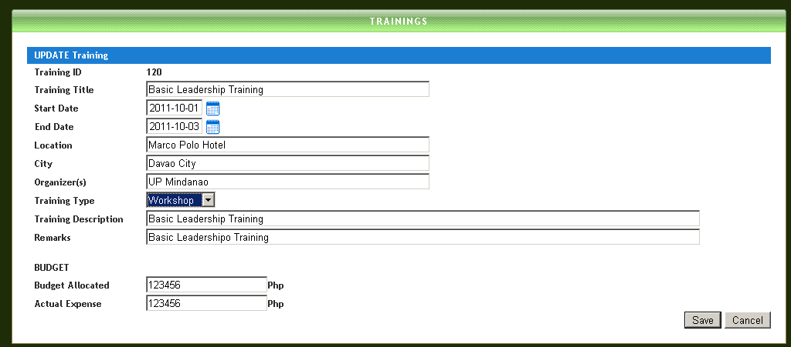
It will redirect to a page which looks like adding a new training but with values. Editing these values, then clicking ‘Save’ will update the database.

Hitting ‘Cancel’ will abort the update process and redirect to the list.
The second way to add a Training is to go to view a training, and then look for icon on the upper right of the page. This will redirect the user to the same edit page as shown above.

HOW TO DELETE A TRAINING
To delete a training, look for the third icon, which looks like this: , under the ‘Action’ column.
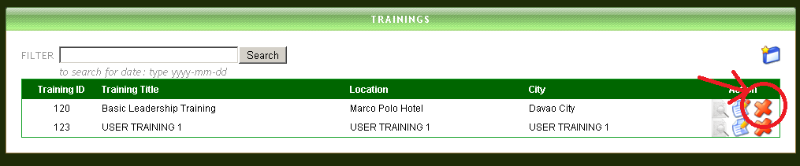
It will prompt the user if he is sure on deleting the training, click ‘Ok’ to continue or ‘Cancel’ to go back to the previous page.
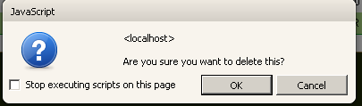

SEARCH
To search for a training, type in the keyword in the search bar located on the upper left of the page then hit ‘Search’
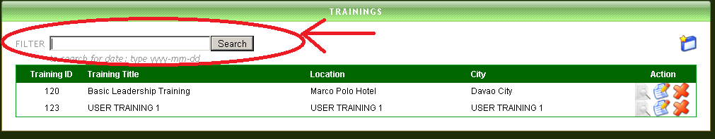
Users can also search for training title, location, city, training type, training organizers, and date.
ADMINISTRATORS can also search for participants, and then search results will show the trainings attended by that participant.

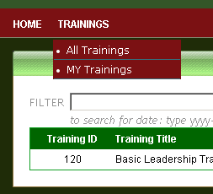
MENU
Administrators and Users have different menu. For Administrators, the menu offers them 2 choices: All Trainings and My Trainings.
Clicking ‘All Trainings’ will redirect the administrator to the list of all trainings in the database.
Clicking ‘My Trainings’ will redirect the administrator to the list of his trainings.
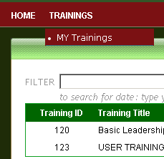

Users only have one item in their menu – ‘My Trainings’. Clicking this menu will always redirect users to the list of the trainings that they have participated.

Clicking ‘HOME’ will redirect the user to the main menu.

LOGGING OUT
To logout, click the ‘Logout’ located below the complete name of the user on the upper right of the page.